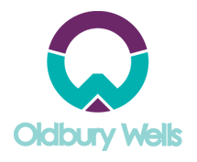
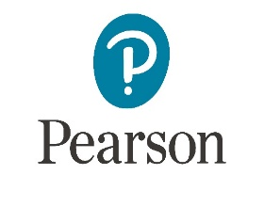
Extended Certificate/National Diploma
Health & Social Care Summer Work

Unit 1 Human Lifespan Development
Health and social care practitioners need to develop a knowledge base for working with people in every stage of their lives, and they need to know how their own experiences relate to health and wellbeing. Although it is generally accepted that there may be deterioration in health with age following adulthood, medical intervention means people are living longer and have better life prospects.
Topic A: Human growth and development through the life stages

Task 1: Word Glossary - Define the following terms:
- Growth
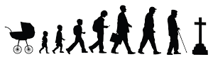
- Development
- Developmental norms
- Developmental milestones
- Life course
- Maturation
- Life expectancy

Task 2: Identify and describe 4 areas of development and life stages
Resource Links: 8 Stages of Development by Erik Erikson https://www.youtube.com/watch?v=aYCBdZLCDBQ

Topic B: Intellectual development across the life stages

Task 3: Identify the role of the Piaget Model and Chomsky Model used in assessing infancy and early childhood growth in intellectual and language skills.

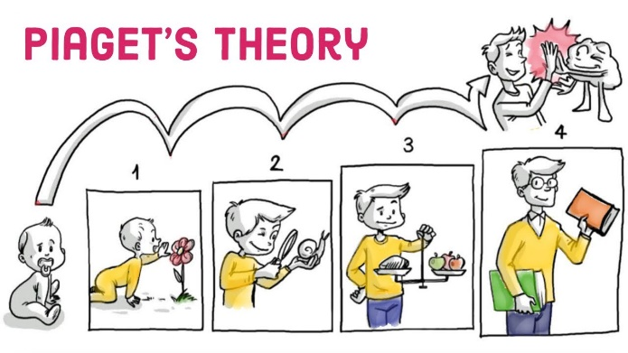
Resources Links: Piaget’s Theory https://www.youtube.com/watch?v=IhcgYgx7aAA
Chomsky Model https://www.youtube.com/watch?v=7Cgpfw4z8cw

