Breaking Bad Chemistry Calculations
Scenario:
Walt uses the Nagai method to produce his crystal meth. It follows two steps as shown below:
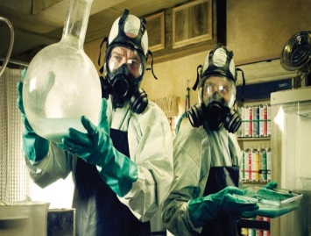
Step 1: Ephedrine + hydroiodic acid → iodoephedrine (+ water)
C₁₀H₁₅NO + HI → C₁₀H₁₅NI (+ H₂O)
Step 2: Iodoephedrine + phosphorous → methamphetamine + phosphorous triiodide
3C₁₀H₁₅NI + P → 3C₁₀H₁₅N + PI₃

TASK 1: Calculate the relative formula mass for each of the following compounds:
- Phosphorous (P) ___________________________________________________
- Phosphorous triiodide (PI₃) ___________________________________________________
- Hydroiodic acid (HI) ___________________________________________________
- Methamphetamine (C₁₀H₁₅N) ___________________________________________________

TASK 2:
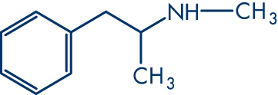
The reactive component in methamphetamine is called the amine group (formula NHCH₃). Calculate the percentage (%) by mass of this group in the overall compound (C₁₀H₁₅N).

Remember: (A_{r} ÷ M_{r}) x 100

Extension: Calculate the % of each of the following in methamphetamine:
- Carbon ___________________________________________________
- Hydrogen ___________________________________________________
- Nitrogen ___________________________________________________

TASK 3: Reacting Masses (Higher)
The equation in step 2 shows that 3 moles of iodoephedrine react to form 3 moles of methamphetamine.
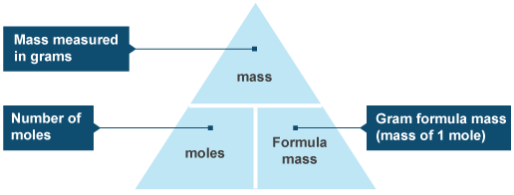
The equation in the formula triangle below can be used to work out the mass of product that could theoretically be formed from a certain mass of reactant.

Based on the number of moles given above, and the formula masses of each compound, calculate the mass of:
  - Iodoephedrine
  - Methamphetamine
Hint: use the formula triangle!

TASK 4: Percentage yield (Higher)
Percentage yield = $\frac{amount of product produced}{theoretical maximum}×100$
E.g. A + B → C
Using known masses of iodoephedrine (828g) it was worked out that the maximum amount of methamphetamine that could be produced was 447g. However when Jesse did this reaction he only produced 300g.
What was his percentage yield?

Extension: On the second attempt, a more established cook (Walt) had a crack at the method and managed to produce 400g.
- What was his percentage yield?

- Explain why a greater % yield is beneficial for Walt.

