Last minute Unit 2 Exam Advice
Raise your level of literacy and make writing legible
Avoid using the word “help” – if possible use other terminologies eg. If it’s a care worker use “offers assistance”, if it’s a GP use “diagnose, advise, treat prescribe etc”, if it’s a nurse use “assists with personal care tasks”

Avoid using the word “thing”, find a more suitable word, such as “factor” or “aspect”
When discussing anything to do with equality, avoid using “treats equally” and replace it with “treats fairly and not disadvantaged”

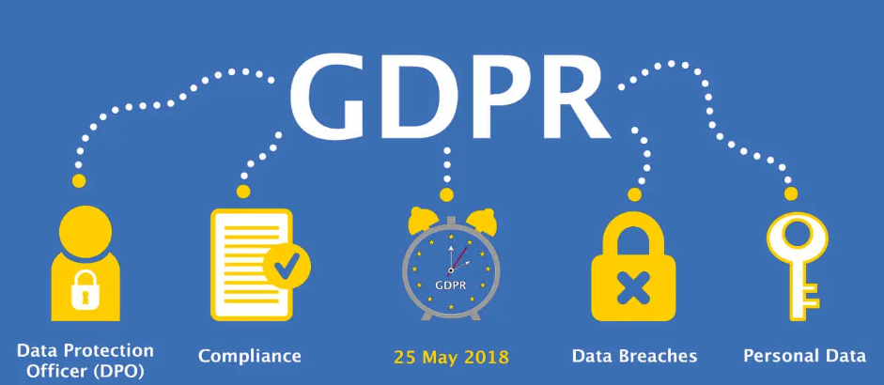
When faced with a question about confidentiality or personal information…
Start your answer with…. [suggestion; learn this off by heart]
Care workers must abide by the guidance offered in the legislation, the General Data Protection Regulations and the care settings (name the care setting if possible) Confidentiality Policy, such as keeping all personal information stored securely, such as using pass words on a computer and locking the screen when not in use. It’s also worth showing that you know about “need to know basis” and consent.

When you are asked to discuss – access to services……
- Include the name of the barrier
- Explain it, making it relevant to the case study
- Give actual examples and if it’s an 8 or 10 mark question, say the impact that has on the service user.
- Sow your complete knowledge in a discussion, to discuss the ways the barrier can be overcome, such as the volunteer drivers scheme or free prescriptions or counselling etc

When asked to explain the managers responsibility towards employees
Start your answer with…. [suggestion; learn this off by heart]
The manager (name the care setting from the case study if possible) must ensure all care workers/nurses are given induction that includes training about all the policies and procedures so they are working within the UK laws, such as the Equality Act. Existing staff will need annual CPD that will include refresher training and the up-dates in any polices, such as changes to the Safeguarding Policy.
According to the Health and Safety at Work Act, manager are responsible for providing PPE kit, such as aprons and latex gloves, which prevent cross-infection. However, it is then the responsibility of the staff themselves to wear the protective items.
When asked to explain the care workers responsibility towards service users
Similar to above, start your answer with…. [suggestion; learn this off by heart]
The care worker must ensure they attend training about all the policies and procedures so they are working within the UK laws, such as the Equality Act. It is then there responsibility to work within this legal guidance as well as their professions codes or practice (or Care Certificate if it’s a residential care worker), such as not accept expensive gifts from service users
According to the Health and Safety at Work Act, manager are responsible for providing PPE kit, such as aprons and latex gloves, which prevent cross-infection but it is then the responsibility of the staff themselves to wear the protective items.

