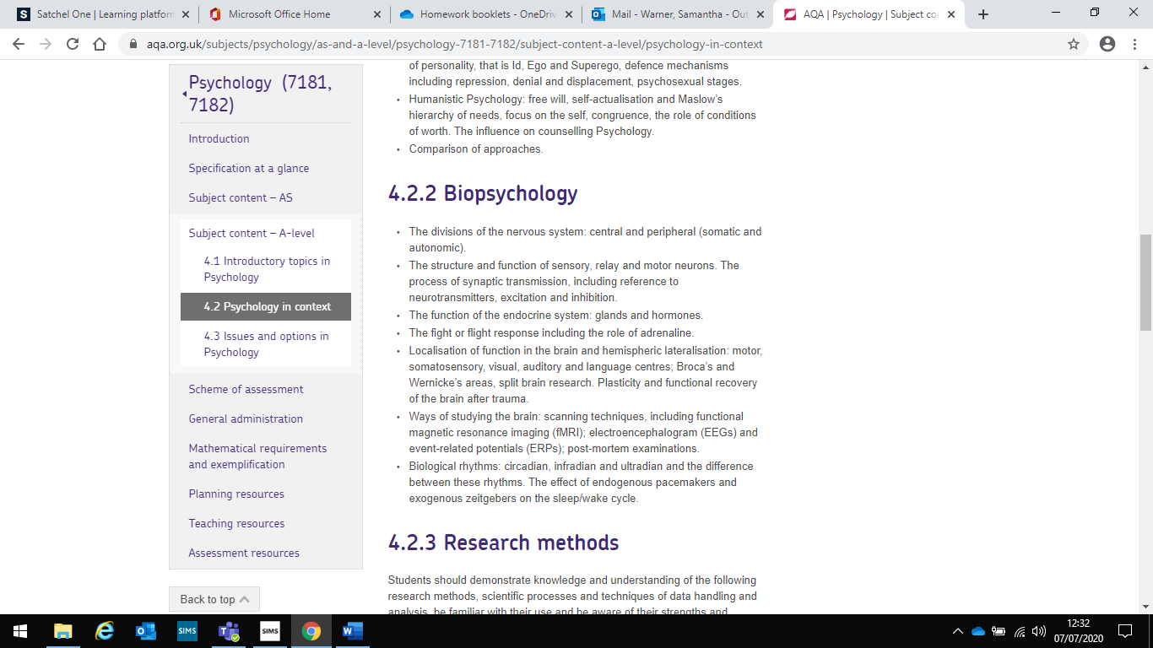

Neurons and synaptic transmission:

**Motor neuron** – passes information to muscles to assist voluntary movement. Cell body found in CNS and axon projects outside of spinal cord to glands and muscles

**Relay neuron** – passes info from sensory to motor neurons, found in CNS only

**Sensory neuron** – picks up sensory information from sensory receptors. Found in receptors like eyes, ears, tongue and skin, and they carry info to CNS (most to brain, some stop at spinal cord = reflex actions)

**Synaptic transmission** – electrical impulse fires down the axon, reaches the **vesicles** (found in dendrites) which release neurotransmitters into the synapse. **Neurotransmitters** chemically diffuse across the synapse and stimulate **post-synaptic receptor sites** to continue the message.

**Excitation** – increases positive charge, more likely to fire, e.g. adrenaline. **Inhibition** – causes negative charge, less likely to fire e.g. serotonin. Summation – excitatory and inhibitory influences are summed.

Biological rhythms: circadian, infradian, ultradian:

**Circadian** – subject to a 24-hour cycle e.g. sleep-wake cycle which is controlled by daylight. Siffre and Aschoff and Ruter Wever all found that when deprived of light his sleep-wake cycle remained close to a 24-hour cycle. Folkard also found that when he adjusted the clock without participants knowing they struggled to adjust to the change in the length of the day and kept a 24-hour cycle – circadian rhythm is hard to over ride

**Infradian** – less that one cycle in 24 hours e.g. menstruation and SAD. Female cycle takes on average 28 days to complete. During each cycle, oestrogen rises and causes an egg to release (ovulation). Progesterone prepares the body for pregnancy and if this doesn’t occur, the egg is absorbed, and womb lining released (menstrual flow). SAD is referred to as winter blues, triggered by the winter months, subject to a yearly cycle. It is thought that melatonin is implicated in the cause of SAD as it effects serotonin levels

**Ultradian** – More than 1 cycle in 24 hours e.g. sleep stages. 5 stages of sleep that span approximately 90 mins, cycle continues throughout each night. Stages 1&2 – light sleep (alpha waves slowing to theta waves), 3&4 – deep sleep (delta waves), 5 – REM sleep resembles the awake brain, most likely to dream in this stage

Ways of studying the brain:

fMRI: detects changes in blood oxygenation. When a brain area is active it consumes more oxygen, which shows up as light on the scan to see which areas are active

EEG: measure electrical activity within the brain via electrodes attached to the skull cap. The scan recording shows brainwave patterns – often used to indicate things such as epilepsy

ERP: uses a statistical averaging technique. Filters out extraneous brain activity and leaves only responses relating to a specific stimulus. Different brain waves show different activity

Post-mortem: analysis of a person’s brain after death. Likely to study those with a rare disorder or unusual deficits. Areas of damage examined and compared to functioning brain

The nervous system and end endocrine system:

**The nervous system** = central nervous system (CNS); brain and spinal cord & peripheral nervous system (PNS); somatic nervous system (controls muscle movement) & autonomic nervous system (governs vital systems e.g. breathing); sympathetic nervous system, parasympathetic nervous system

**Endocrine system** = works alongside nervous system to control vital functions, acts slower but is widespread. Glands produce hormones which are secreted into bloodstream and effects cells which have receptors for that particular hormone e.g. pituitary gland (master gland) controls release of hormones from other endocrine glands, thyroid secrets thyroxine, testes secret testosterone

Endocrine and ANS working together: fight or flight

When a stressor is perceived, hypothalamus triggers activity in **sympathetic nervous system** (part of ANS). ANS changes from parasympathetic to sympathetic. Adrenaline is released into bloodstream from **adrenal gland** causes changes (e.g. increased heart rate) which prepare the body for fight or flight. Once the threat has passed the parasympathetic nervous system takes over and returns bodily functions to normal

Plasticity and functional recovery:

**Plasticity** – the brains tendency to change and adapt as a result of experience and new learning, most synaptic connections form by 2-3 years. As we age rarely used connections are pruned and commonly used ones strengthened.

**Research** – **Maguire** (London taxi drivers showed more grey matter areas of the brain associated with spatial awareness & navigation). **Draganski** (found learning induced changes in brains of medical students when comparing brain images 3 months before exams and 3 months after).

**Functional recovery after trauma** – a type of plasticity. Healthy areas of the brain take of the damaged area. Spontaneous recovery can occur and then rehabilitation is needed. Secondary neural pathways are **unmasked**. **Axonal sprouting** = growth of new nerve endings to connect with undamaged cells. Recruitment of similar areas in the other hemisphere.

Biopsychology

Localisation of function:

The idea that different parts of the brain are responsible for different processes, holistic theory believes all parts of the brain are involved

**Motor area** – located in frontal lobe, responsible for voluntary movement. **Somatosensory area** – located in parietal lobe, responsible for sensory information. **Auditory areas** – located in the temporal lobe, responsible for analysing speech based information. **Visual areas** – located in occipital lobe, responsible for visual information. **Broca’s area** – left frontal lobe, responsible for speech production. **Wernicke’s area** - left temporal lobe, responsible for understanding speech

Endogenous pacemakers and exogenous zeitgebers:

**Endogenous pacemakers** – **the suprachiasmatic nucleus** = tiny bundle of nerve cells in the hypothalamus – influential in maintaining sleep/wake cycle. It receives information about light levels passes information to the pineal gland which produces more melatonin when needed to induce sleep. The SNC also enables the biological clock to adjust. Animal studies to support the role of SCN in maintaining the circadian sleep/wake cycle

**Exogenous zeitgebers** - **Light** = has an indirect influence on key processes which control bodily functions such as hormone secretion (e.g.melatonin). Light can still have an influence when our eyes are closed. **Social cues** = routines imposed by parents help to set biological rhythms for babies by 16 weeks old e.g. when they feed them and put them to bed. Sticking to social cues of a country you’ve travelled to is thought to overcome jetlag

Lateralisation and split brain:

**Hemispheric lateralisation** = idea that 2 hemispheres are functionally different e.g. language controlled by left

**Split brain patients** = had corpus callosum severed to stop epileptic seizures spreading. **Sperry** presented pictures to patients left or right visual field, patients had no communication between hemispheres

Findings:

Pictures in RVF – patients could verbally express what they had seen

Pictures in LVF – patients would report seeing nothing. They could (using their left hand) pick the matching object from a grab bag.

Words to both VF – patient would verbalise word to the RVF but select the matching object to the word shown in LVF

Right hemisphere also appeared dominant for facial recognition