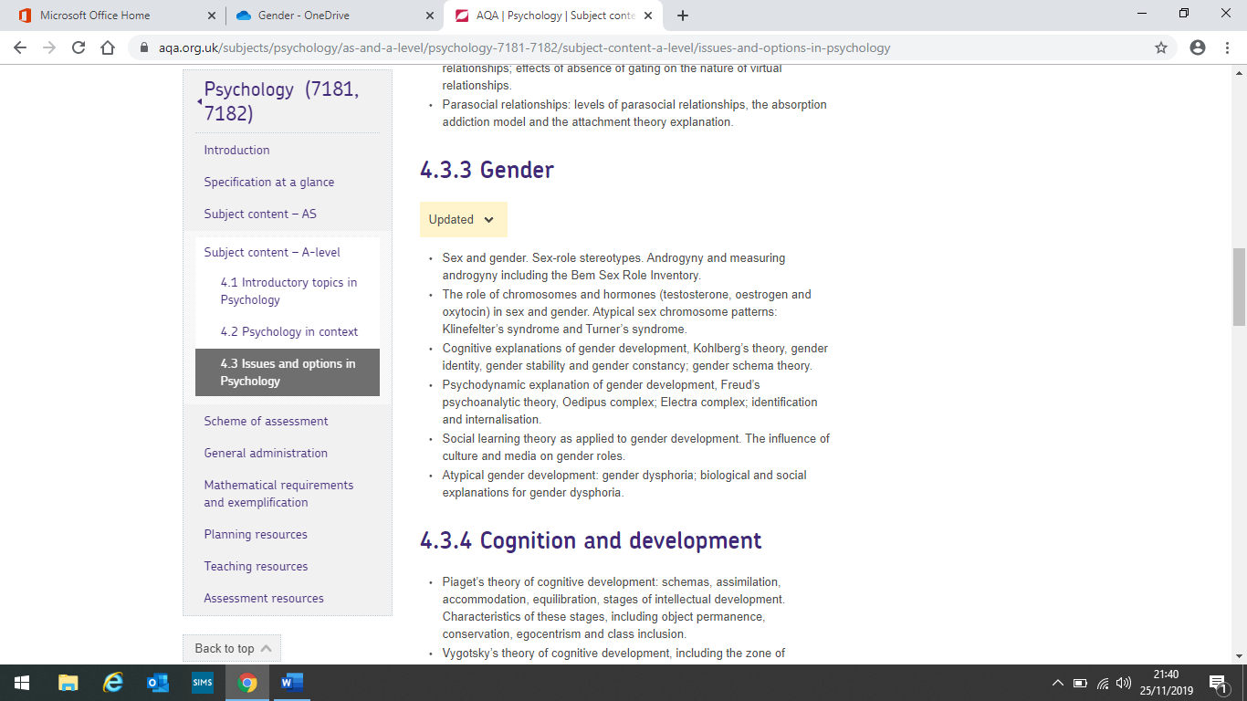

Gender

The role of chromosomes and hormones:

23 pairs of chromosomes, 1 pair determine sex - XX = female XY = male

Y chromosome carries an SRY gene - produces androgens - stimulates the growth of male sex organs. Hormones have an impact prenatally in the womb and at puberty on gender development

Testosterone = produced mainly in testes and associated with aggression. Oestrogen = plays an important role in the menstrual cycle. Oxytocin = stimulates lactation, known as the love hormone

Atypical sex chromosome patterns:

**Klinefelter’s syndrome** – affects between 1 in 500 to 1 in 1000 biological males and they have an additional X chromosome XXY. 2/3’s of people with it are unaware

Characteristics – gangly limbs, underdeveloped genitals, general clumsiness, poor reading ability, shy, lack of interest in sexual activity , issues with memory and problem solving

**Turner’s syndrome** – affects females as they have 45 chromosomes not 46 so XO.

Characteristics – no menstrual cycle, webbed neck, no breasts developed immature appearance and social ability, difficulty fitting in

Social learning explanation of gender development:

A way of explaining behaviour that includes both direct and indirect reinforcement, combining learning theory with the role of cognitive factors

Direct reinforcement – children are more likely to be reinforced for gender-appropriate behaviour

Indirect reinforcement – children are more likely to repeat behaviours they have seen get rewarded

Identification and modelling – children identify with role models, they are most likely to be attractive, similar to them and high status. Children will then imitate the modelled behaviour and they are more likely to copy same-sex role models

Mediational process – attention, retention, motivation and motor reproduction

Cognitive explanations

Kohlberg’s theory – a child’s understanding of gender becomes more sophisticated with age, transition through the stages is gradual.

**1 Gender identity** (around age 2) – correctly identify themselves as a boy or girl, not aware sex is permanent

**2 Gender stability** (around age 4) – realise they will always stay the same gender but cannot apply this logic to others

**3 Gender constancy** (around age 6) – gender is constant across time and situation, children will seek gender appropriate role models

Gender Schema theory:

**Gender schema** – organised set of beliefs and expectations related to gender. Once a child has established gender identity around age 2-3 they will search for information to encourage gender schemas

By age 6 children have fixed stereotypes about what is gender appropriate and disregard information that doesn’t fit with this

**Ingroups and outgroups** – own gender is ingroup, they understand their ingroup more and prefer them. Ingroup boosts child’s self-esteem. Until age 8 when children can develop schemas for both genders.

Androgyny and the BSRI:

**Androgyny** – displaying a balance of masculine and feminine characteristics in one’s personality. Individuals who are a mix of masculine and feminine traits are thought to be better equipped to adapt to a range of situations

**Bem’s Sex Role Inventory (BSRI)** – The first systematic attempt to measure androgyny using a rating scale of 60 traits (20 masculine, 20 feminine and 20 neutral) to produce scores across 2 dimensions: masculinity-femininity and androgynous-undifferentiated

Feminine items – affectionate, gentle. Masculine items – aggressive, forceful

Respondents are required to rate themselves on a seven-point rating scale for each item. Scores are then classified on the 2 dimensions.

Sex and gender:

**Sex** – The biological differences between males and females including chromosomes, hormones and anatomy

**Gende**r – The psychological and cultural differences between males and females including attitudes, behaviours and social roles

**Gender identity disorder (GID)** – when your gender identity and biological sex do not match up

**Sex-role stereotypes** – A set of beliefs and preconceived ideas about what is expected or appropriate for males and females in a given society e.g. girls wear pink and boys wear blue

Psychodynamic explanations of gender development:

Freuds psychoanalytic theory

**Pre-phallic children** – Freud states children develop through 5 psychosexual stages. Gender development occurs in the phallic stage. Prior to this stage children have no gender identity

**Oedipus complex** – boys fancy their mother and fear their Dad will castrate them. Eventually they identify with their father and internalise their behaviours

**Electra complex** – girls have penis envy and fancy their Dad. Eventually they replace this for a desire for a baby and identify with their mother and internalise her behaviours

**Identification and internalisation** – children identify with their same-sex parent after resolving the Oedipus/Electra complex. Children then internalise the behaviours of their same-sex parent and gain their gender identity

**Little Hans** – supports the idea of the Oedipus complex – Freud stated he had **displaced** his fear of father castrating him onto horses

The influence of culture and media on gender roles:

Culture and gender roles – **Mead (1935)** studied tribal groups = Arapesh were gentle, Mundugumor were aggressive, Tchambuli women dominant. Suggests gender roles may be culturally determined.

**Cultural similarities** – Buss found consistent patterns in mate preference , women sought men for wealth and resources, men looked for youth and attractiveness

Media and gender roles – media provides role models who children imitate. **Rigid stereotypes** are portrayed reinforcing gender stereotypes e.g. women being unambitious. Children who have more exposure display more stereotypical views

Atypical gender development:

Gender dysphoria is recognised and diagnosed using the DSM-5

Biological explanations:

**Brain sex theory** – biological sex doesn’t match brain structure

**Genetic factors** – Twin studies suggest a heritable component to GID

Social-psychological explanations:

**Psychoanalytical theory** –separation anxiety occurring before gender identity has been established so son ‘becomes’ mother

**Cognitive explanation** – gender schema directs gender-appropriate behaviour. Personal interests influence gender schema (dual pathway).