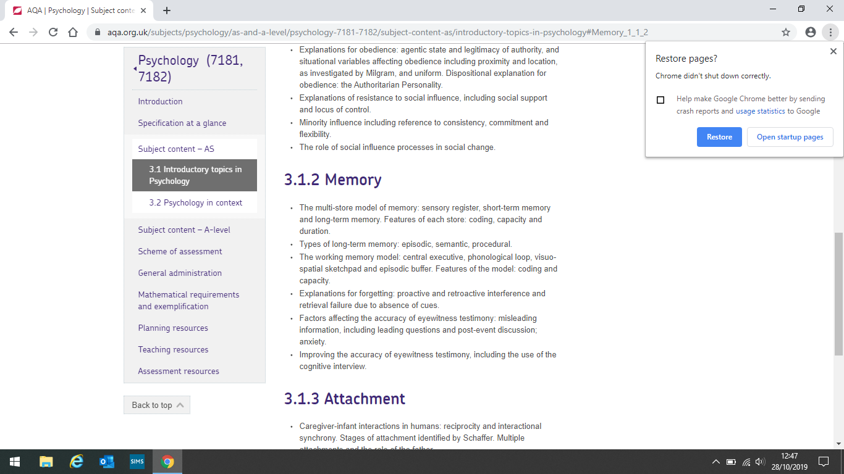

Improving EWT; the cognitive interview:

A method of interviewing formed by Fisher and Geiselman eyewitnesses used by the police to help them retrieve accurate memories.

**Report everything** – witnesses encouraged to give every single detail which might trigger other important memories

**Reinstate the context** – witnesses should return to the scene of the crime in their mind e.g. remembering the weather or how they were feeling. This is to reduce context-dependent forgetting

**Reverse the order** – events should be recalled in a different order e.g. end to start to prevent reporting expectations and avoids dishonesty

**Change perspective** – witnesses should recall incident from the point of view of somebody else. This is done to disrupt schemas

**The enhanced cognitive interview (ECI**) – Fisher developed additional elements which focused on dynamics. He added things like using appropriate eye contact, reducing anxiety, minimising distractions and using open-ended questions

Memory

Types of long-term memory:

Tulving stated MSM was too simplistic and suggested there was 3 different types of LTM

**Episodic memory** – a store for personal events (episodes) throughout life e.g. first day at school or a big birthday. Memories have to be consciously retrieved. They are time-stamped so we can remember when they happened

**Semantic memory** – a memory store for our knowledge of the world e.g. facts and definitions. Usually need to be deliberately recalled

**Procedural memory** – a memory store for our knowledge of how to do things e.g. learned skills like riding a bike or driving. We usually recall these memories without consciously thinking about it or making deliberate effort.

Factors affecting eyewitness testimony:

Misleading information:

**Leading questions** – investigated by Loftus and Palmer. Showed participants a video of a car accident and asked them to estimate the speed of the car. Each time they changed the verb e.g. how fast were the cars going when they bumped, contacted, collided, hit and smashed int each other. The mean estimate speed was highest for the verb smashed and lowest for the verb contacted.

**Post-event discussion** – investigated by Gabbert et al. Showed half the participants a scene from one perspective and half the scene from another. The eyewitnesses who discussed what they saw reported information which was not possible for them to have seen. Participants with no discussion did not.

**Anxiety has a negative effect on recall –** anxiety causes arousal which prevents us paying attention or creates weapon focus as investigated by Johnson and Scott. Participants who saw a man carrying a knife had worse recall of the man than participants who saw a man holding a pen.

**Anxiety has a positive effect on recall** – anxiety causes arousal which increases alertness. Investigated by Yuille and Cutshall who interviewed witnesses of a real life shooting in Canada. Eyewitnesses were very accurate and there was little change when asked again in 5 months

**Yerkes-Dodson law** – the relationship between emotional arousal and performance looks like an inverted ‘U’. When applied to EWT – lower levels of anxiety produce lower levels of accuracy, as anxiety increases so does the accuracy of recall. However after an optimal level of anxiety is reached where recall is at its best, any more stress will decrease accuracy again

Explanations for forgetting:

Interference theory – occurs when two pieces of information conflict with each other leading to forgetting one or both memories. Proposed as an explanation mainly for forgetting in the LTM.

**Proactive interference** – old memories interfering with new memories e.g. forgetting new people’s names because you know old friend’s names

**Retroactive** – new memories interfering with old memories e.g. new friend’s names causing you to forget old friend’s names

**Effects of similarity** – McGeoch and McDonald studied retroactive interference. Participants learned a list of words until they could remember with 100% accuracy. They then learned a new list which were either: synonyms, antonyms, unrelated words, nonsense syllables, three-digit numbers or no new list and recalled the first list again. They found that the material which was most similar had the worst recall. This shows that interference is strongest when the memories are similar

Retrieval failure – occurs when we don’t have sufficient cues to access a memory

**Encoding specificity principle** – If a cue is present at learning and has been encoded, then it must be present at recall to make it as accurate as possible

**Context dependent forgetting** – external cues. Studied by Godden and Baddeley who found that divers who learned words underwater and on land recalled the words better when in the same environment they learned them

**State-dependent forgetting** – internal cues. Carter and Cassaday got participants to recall word lists on drowsy medication and without and found that they remembered more when in the same state as they learned them

Working memory model:

Is an explanation of how the short-term memory is organised, and how it functions. It is concerned with which part of the brain is active when we are performing different tasks.

**Central executive** – Monitors incoming information, makes decisions and allocates slave systems to tasks.it has very limited capacity

**Phonological loop** – deals with auditory information (coding is acoustic) and preserves the order that information arrives. Made up of **phonological store** – stores words you hear and the **articulatory process** – repeats words on a loop 2 seconds worth of what you can say

**Visuo-spatial sketchpad** – stores visual and spatial information. Made up of the **visual cache** – stores visual data and the **inner scribe** – records arrangement of objects in a visual field

**Episodic buffer** – Added to the model in 2000 and is a temporary store for information. It integrates visual, spatial and verbal information and maintains time sequencing. It is the storage component and has limited capacity. It links working memory to the LTTM.

Coding, capacity and duration and the multi-store model of memory:

**Coding** – the format in which information is stored in various memory stores

Baddeley – found the coding of the STM is acoustic and LTM is semantic

**Capacity** – the amount of information that can be held in a memory store

Jacobs – found the mean digit span people can remember is 9.3. Miller – found the capacity of the STM is 5-9 items

**Duration** – the length of time information can be held in memory

Peterson & Peterson – duration of STM is 18-30 seconds without rehearsal

**Multi store model** – **sensory register** take in all sensory information e.g. sound; has a large capacity but duration of less than a second. Information which we pay attention to passes to STM. **STM** – coded acoustically, capacity of 5-9 items, duration of 18-30 seconds, maintenance rehearsal passes information to LTM. **LTM** – potentially unlimited capacity and duration and coding is mainly semantic. Information must be retrieved to STM to allow recall